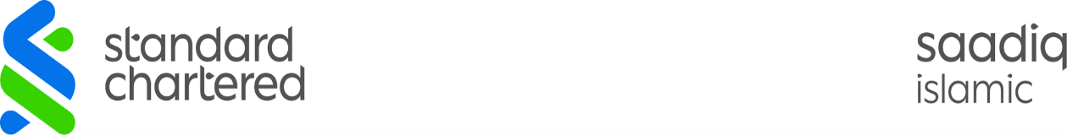

Dear Client, | Alerts  August 12 2024, 03:12 PM

A transaction of PKR 8,000.00 has been completed on Acc. Number 01-71***02-01 to ****7706 on 12/08/24 through SC Raast Online Banking. Thank you!
Don't miss out on the latest Standard Chartered promotions & benefits. Visit www.sc.com/pk to find out more!
Thank you
Standard Chartered Bank (Pakistan) Limited

To unsubscribe or modify these alerts, please login to your Online Banking account and select Alerts and SMS Banking. This is a system-generated e-mail and does not require an authorised signature. Please do not reply to the sender of this email.
Please note Standard Chartered Bank will never ask you for your account details. To learn more on important legal notices data protection, our privacy policy and how you can avoid online fraud please visit our website on online security tips at www.sc.com/pk

